**Differences of Well-being score of different Groups:**

My part was to describe the difference between the different groups based on well-being, using python and the methods of Statistics. You can notice in the end, I made two groups based on gender; Male and Female. For each of those group, I have made another sub-group merging the Male and Female group for conducting t-score test, they are Male and Female high screen time, another one is group of Male and Female low screen.

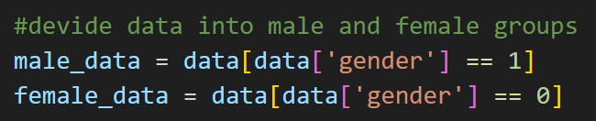

In those groups, using python I have done a Hypotheses test relying on their t-score value. After measuring the t-score value, I have compared the measured value with the P-value, which is 0.05.

The Hypotheses test has two parts of its own. One is Null Hypotheses, and another one is Alternative Hypotheses. Mainly, in a hypotheses test, you have to compare between two different outputs. In my case, I have done the Hypotheses Test according to average screen time and well-being scores for male and female. In which, I assumed “No significant effect of screen time on well-being” as Null hypotheses and “Screen time significantly affects well-being” as Alternative hypotheses. After that, I have conducted the t-score test for Male and Female, and the result I got from it, have compared it with P-value which is 0.05.

After giving python, the command to compare the t-score with p-value, it has rejected the null hypotheses for both male and female showing that, screen time significantly affects well-being.

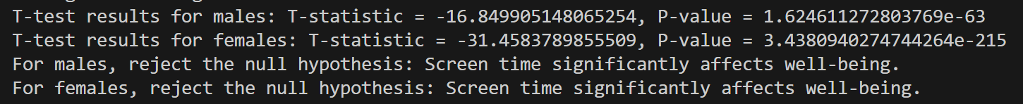

**CONCLUSION:**

After conducting the hypotheses test, we can clearly see that using of high screen time is making many difficulties for a male and female to be well-being. Not only well-being, it also makes many problems for them in finding jobs, enriching the crime rate of society day by day and making everyone separated from each other as they don’t get much time to share. In the end, screen time is significantly affecting well-being of male and female.